TOOL:R Programming RegisterNo:192424335
Name:M.Rishitha Date:10-07-2026
COURSE:Data Handling and Visualization Code: DSA0604

1.Student Academic performance Dashboard
Code:
library(ggplot2)
data <- data.frame(
Attendance = c(85,90,75,60,95,80),
Marks = c(80,90,70,55,95,78),
Department = c("CSE","AI","IT","ECE","CSE","AI")
)
ggplot(data, aes(x=Attendance, y=Marks, color=Department)) +
geom_point(size=4) +
labs(title="Student Academic Performance",
x="Attendance (%)",
y="Internal Marks")

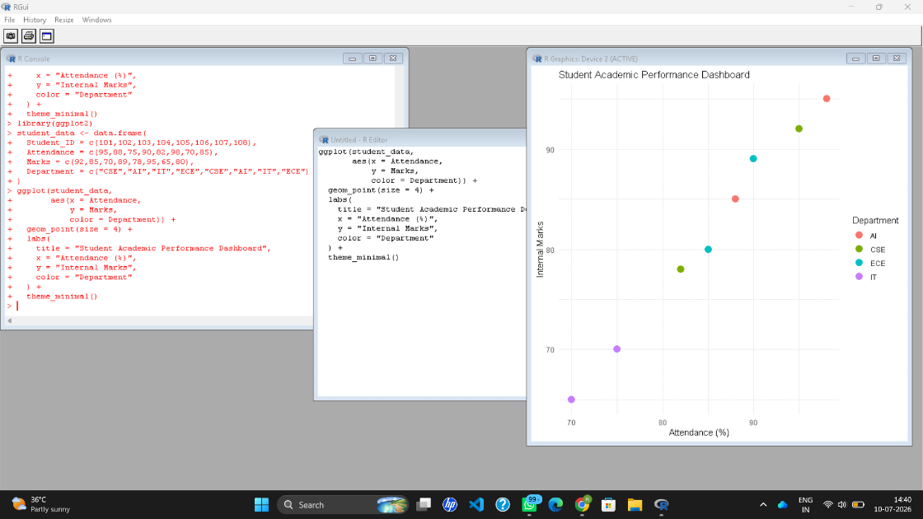
Scenario 2: Electric Vehicle Market Analysis
Code:
library(ggplot2)
data <- data.frame(
Battery=c(30,40,50,60,70),
Price=c(8,10,14,18,22),
Range=c(200,250,300,350,400),
Manufacturer=c("A","B","A","C","B")
)
ggplot(data, aes(Battery, Price,
size=Range,
color=Manufacturer)) +
geom_point() +
labs(title="EV Market Analysis")
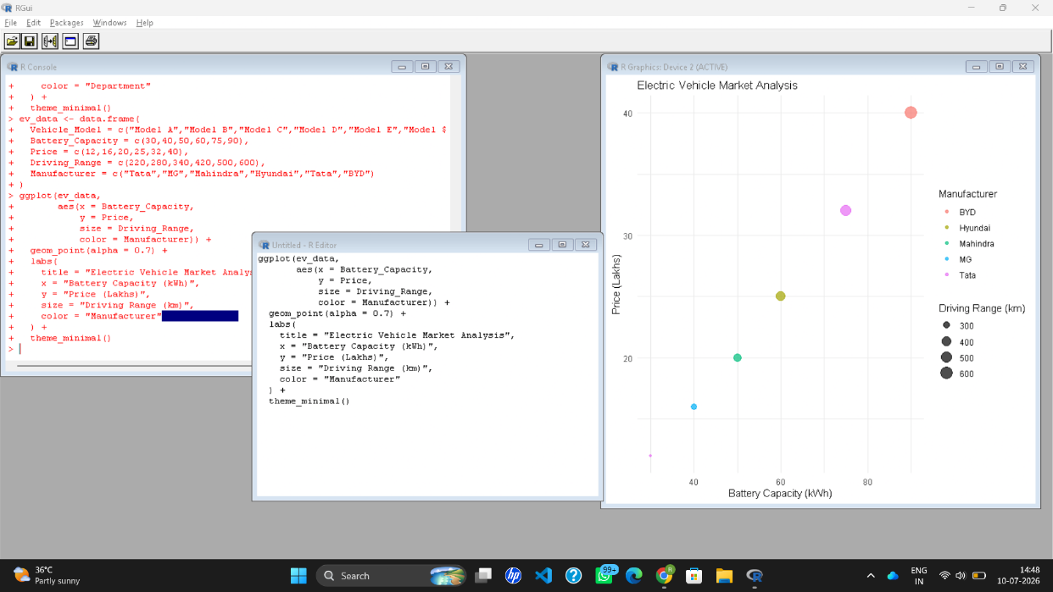
Scenario 3: Hospital Patient Admission Analysis
Code:
library(ggplot2)
data <- data.frame(
Department=c("Cardiology","ENT","Ortho","Neuro"),
Patients=c(120,90,150,110),
Cost=c(5000,3000,7000,6500)
)
ggplot(data,
aes(x=Department,
y=Patients,
fill=Department)) +
geom_bar(stat="identity") +
geom_text(aes(label=Cost),
vjust=-0.5) +
labs(title="Hospital Patient Admissions")

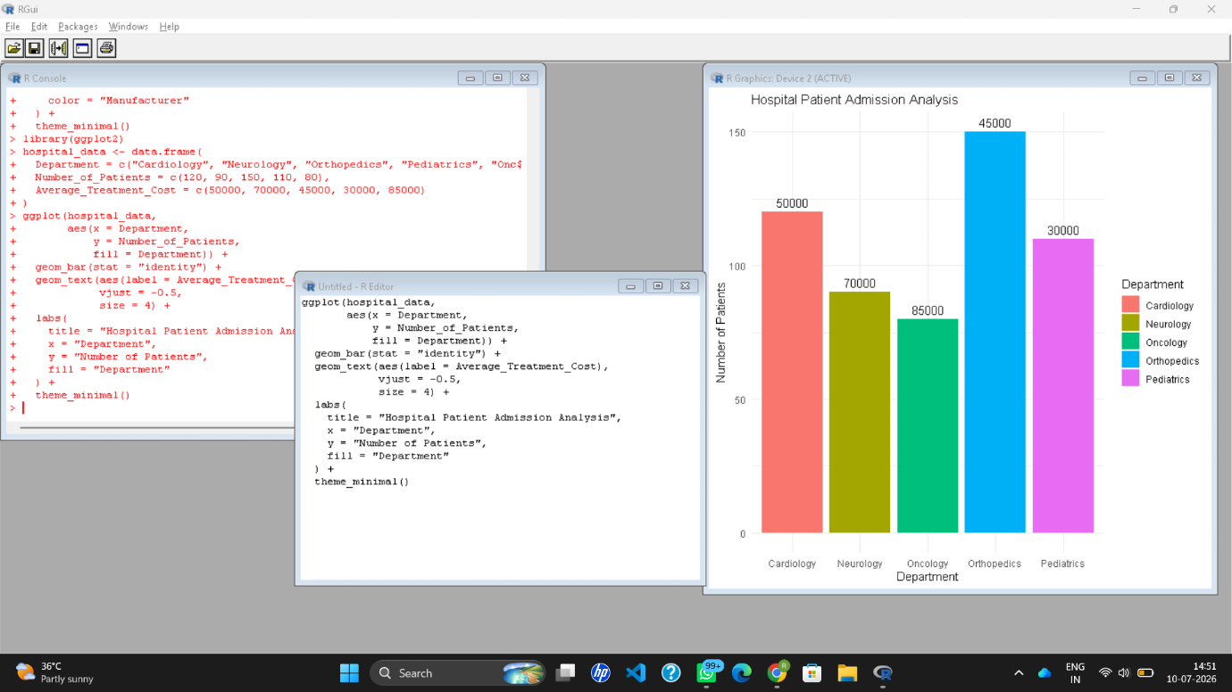
Scenario 4: Weather Monitoring System
Code:
library(ggplot2)
data <- data.frame(
Date=1:6,
Temperature=c(30,31,32,29,33,34,
28,29,30,31,32,33,
26,27,28,29,30,31),
City=rep(c("Chennai","Delhi","Bangalore"),each=6)
)
ggplot(data,
aes(Date,Temperature,
color=City,
linetype=City)) +
geom_line(size=1) +
labs(title="Weather Monitoring")

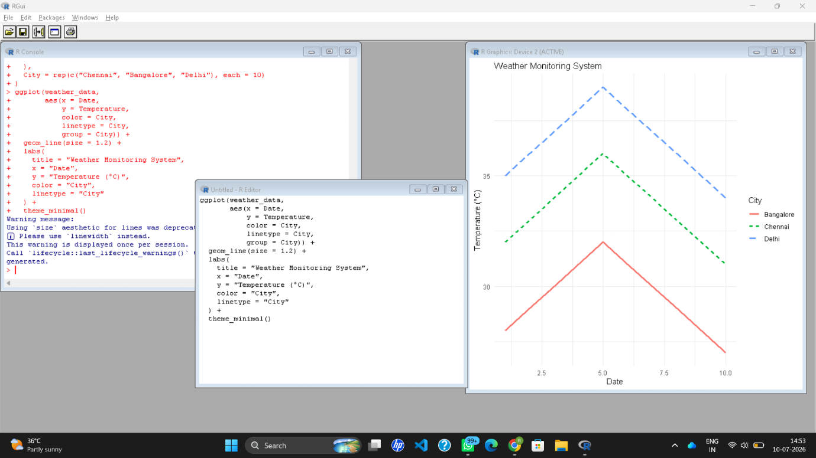
Scenario 5: Supermarket Sales Analysis
Code:
library(ggplot2)
data <- data.frame(
Category=c("Food","Food","Drinks","Drinks"),
Sales=c(100,120,80,95),
Branch=c("A","B","A","B")
)
ggplot(data,
aes(Category,Sales,
fill=Branch)) +
geom_bar(stat="identity",
position="dodge") +
labs(title="Supermarket Sales")

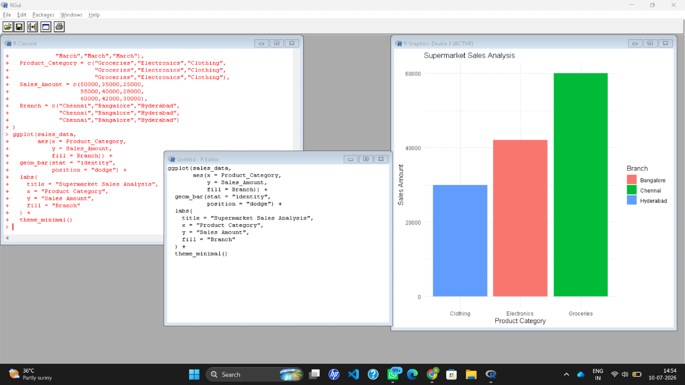
Scenario 6: Employee Salary Distribution
Code:
library(ggplot2)
data <- data.frame(
Salary=c(25000,28000,30000,35000,40000,
45000,50000,55000,60000,70000)
)
ggplot(data,
aes(Salary)) +
geom_histogram(binwidth=5000,
fill="skyblue",
color="black") +
labs(title="Salary Distribution")

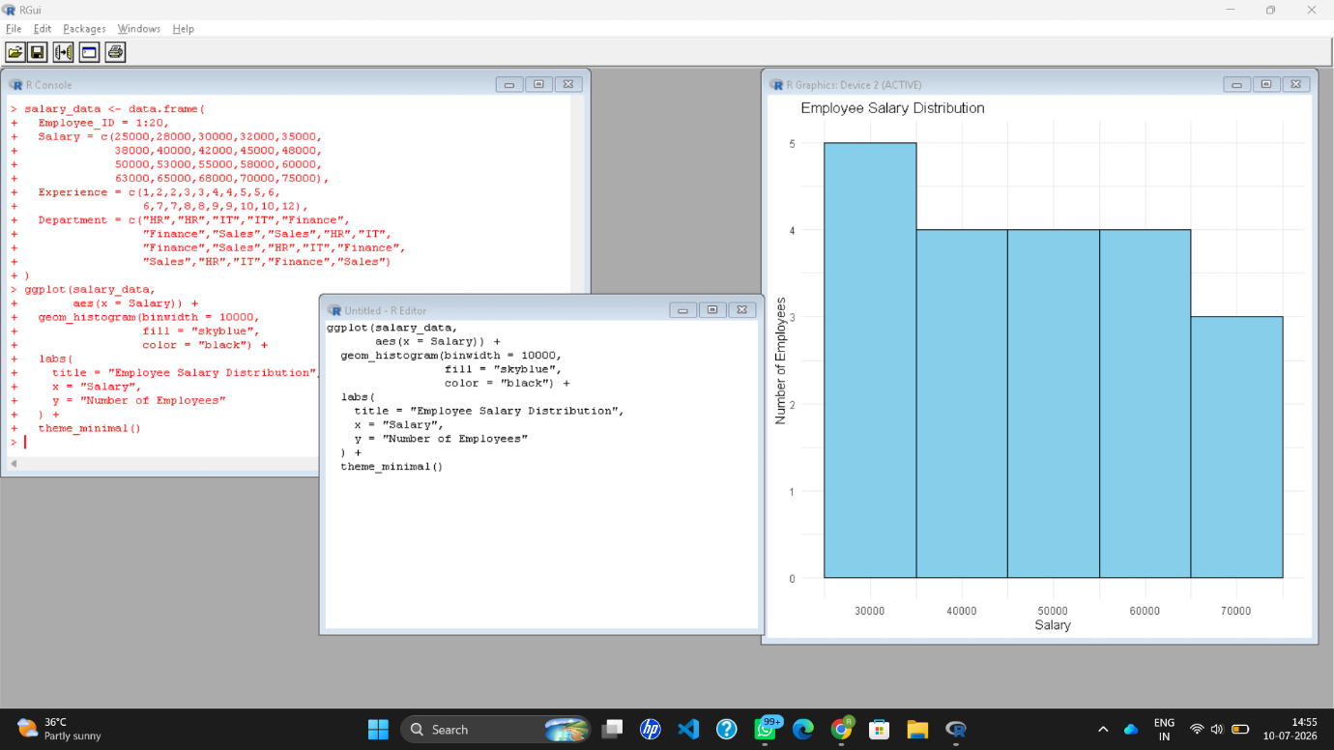
Scenario 7: Smartphone Market Comparison
Code:
library(ggplot2)
data <- data.frame(
RAM=c(4,6,8,12,16),
Price=c(15000,22000,28000,45000,60000),
Brand=c("Samsung","Vivo","Realme","Apple","OnePlus"),
Storage=c(64,128,128,256,512),
Speed=c(2.0,2.2,2.5,3.0,3.2)
)
ggplot(data,
aes(RAM,Price,
shape=Brand,
size=Storage,
color=Speed)) +
geom_point() +
labs(title="Smartphone Market")

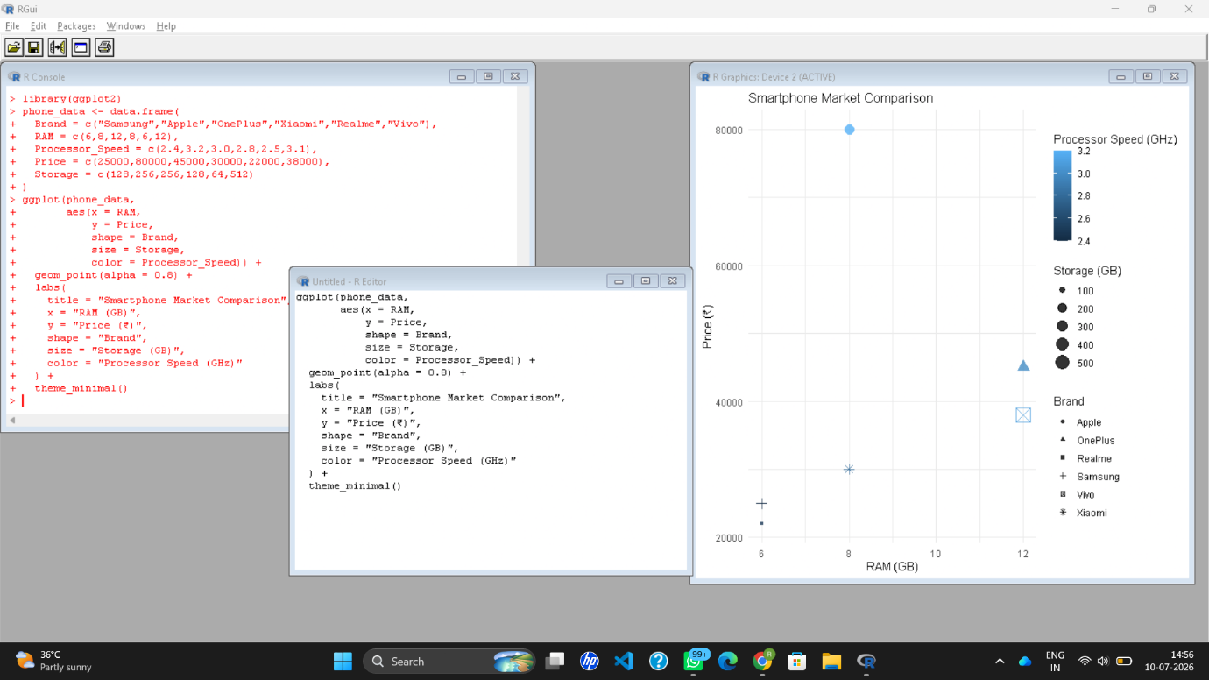
Scenario 8: Online Movie Rating Analysis
Code:
library(ggplot2)
data <- data.frame(
Genre=c("Action","Comedy","Drama","Horror"),
Year=c(2022,2022,2022,2022),
Rating=c(4.5,3.8,4.8,3.5)
)

ggplot(data,
aes(Genre,
factor(Year),
fill=Rating)) +
geom_tile() +
scale_fill_gradient(low="yellow",
high="red") +
labs(title="Movie Rating Heatmap")

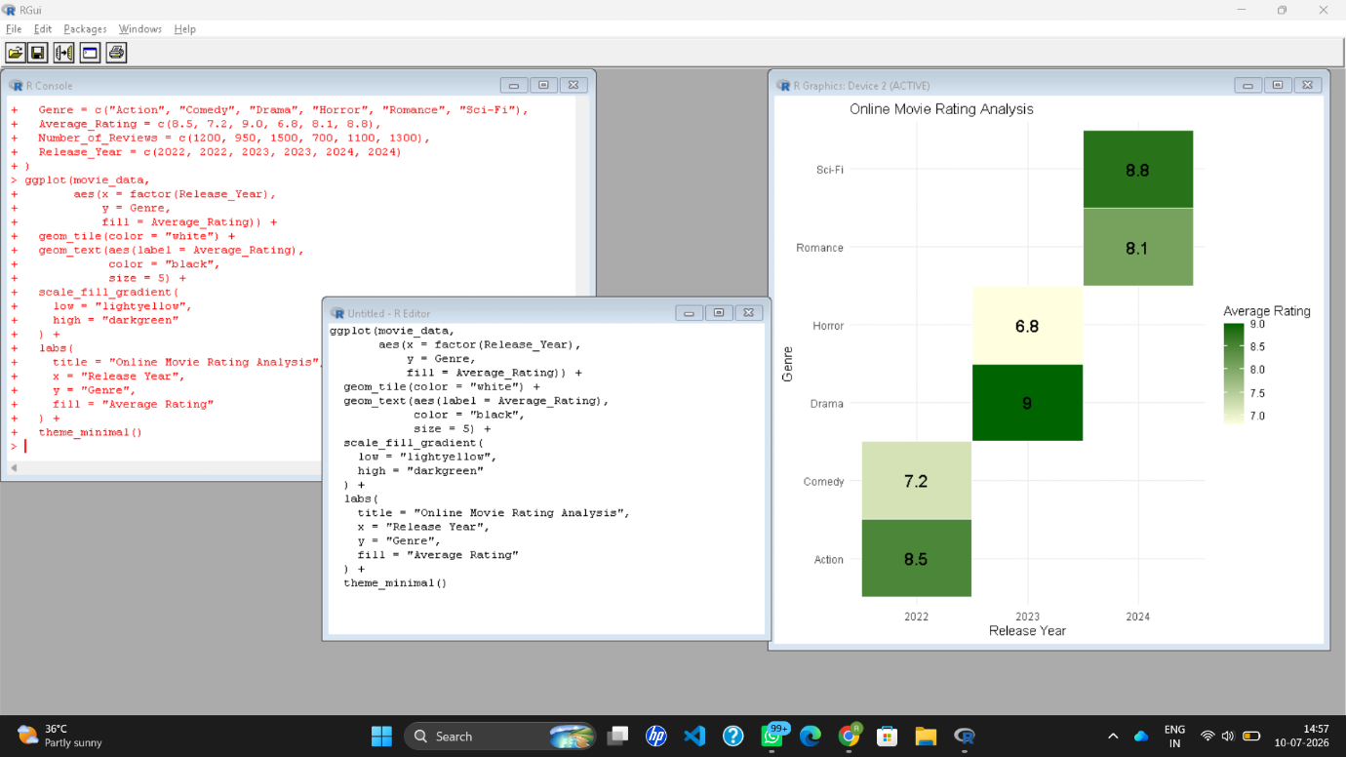
Scenario 9: COVID-19 State-wise Analysis
Code:
library(ggplot2)
data <- data.frame(
State=c("Tamil Nadu","Kerala","Karnataka","Andhra"),
Cases=c(2000,3500,2800,1500)
)
ggplot(data,
aes(State,"COVID",
fill=Cases)) +
geom_tile() +
scale_fill_gradient(low="lightblue",
high="darkred") +
labs(title="COVID State Analysis")
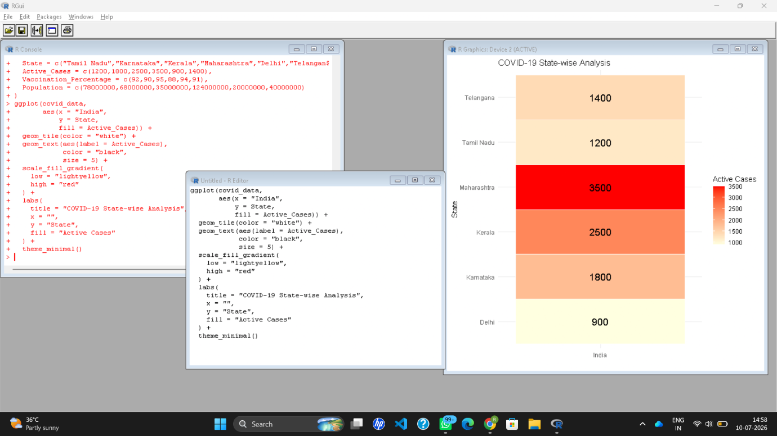
Scenario 10: Iris Flower Classification
Code:
library(ggplot2)
data(iris)
ggplot(iris,
aes(Sepal.Length,
Petal.Length,
color=Species,
shape=Species,
size=Sepal.Width)) +
geom_point() +
labs(title="Iris Flower Classification")

